**Blogging and Procrastination**

Finally, I have made it. I made my mind to write this blog on 7th March,2019 at 01:43 AM. I could not sleep how hard I tried and turned on my laptop to binge watch the latest episodes of my favourite TV Series. Then it struck me. I thought of writing a fully-fledged blog two and a half years ago and still have not done it! So, there I was remembering the time when I wanted to end this endless procrastination in my life after watching a TED talk by Tim Urban (<https://www.ted.com/talks/tim_urban_inside_the_mind_of_a_master_procrastinator> or <https://www.youtube.com/watch?v=arj7oStGLkU> ).

Go ahead. Add this video to watch list !

But jokes apart, this is how how this first article was in cooking.

So, the topic of my first blog post would be about procrastination. I am going to give insight as to why am I procrastinating, what methods can I and the reader adapt to overcome procrastination (or at least try to overcome).

THE DEFINITION

Let us read out what Wikipedia says about Procrastination.

*“Procrastination is the avoidance of doing a task that needs to be accomplished. It could be further stated as a habitual or intentional*[*delay*](https://en.wikipedia.org/wiki/Delayed_gratification)*of starting or finishing a task despite knowing it might have negative consequences. It is a common human experience involving delay in everyday chores or even putting off salient tasks such as attending an appointment, submitting a job report or academic assignment, or broaching a stressful issue with a partner. Although typically perceived as a negative trait due to its hindering effect on one's productivity often associated with*[*depression*](https://en.wikipedia.org/wiki/Depression_(mood))*, low self-esteem, guilt and inadequacy. It can also be considered a wise response to certain demands that could present risky or negative outcomes or require waiting for new information to arrive”.*

The part that I worry about in this whole definition is “despite knowing it might have negative consequences”. When we procrastinate about something let us say an assignment to be submitted to the university, we know that if we do not do it in time, it might affect our grades. We postpone the task until the deadline and manage to pull it off the edge by at least a couple of all nighters. Not shockingly, 80% to 95% of the college students engage in procrastination (Ellis and Knaus 1977) says psychology researchers (Ellis and Knaus 1977).

THE PROCESS

The process of procrastination starts due to several reasons one may discover. Following are some of the reason why we procrastinate according several reports I found:

* Overconfidence
  + We tend to think the task at hand is very easy and we can handle it very well. Thus we come to a conclusion that it is okay to start the task late since we have all the mastery to finish it off within the deadline.
* Not knowing where to begin
  + Consider that the task at hand can be divided into many other smaller tasks. So we often get confused about where to start and thus shy away from working on the task. This situation also arises when there are multiple tasks and we haven’t prioritized them!
* The feeling that a task isn’t so important (Or at least, we don’t care about it so much)
  + This situation is when there are multiple tasks to perform with different priorities and we feel that certain task is not so important when compared to others based on various metrics.
* Laziness
  + A major reason that large number of people fail to achieve their goals in life is due to laziness. It is the major reason people lose their future, career, friends & family!
* Fear of failure
  + When we start to worry about the failing at the task, our mental balance goes downhill and it leads to endless procrastination.

These are the reasons for procrastination that I found worth mentioning in the list or at least I can personally relate to these reasons.

When you start procrastinating, it is the best feeling ever (trust me when I say this)! You are all by yourself and do not have any responsibility or work to handle. Life becomes beautiful and you start to enjoy every moments of your life. You can take morning naps, afternoon naps and a quick evening nap before going to sleep at night!

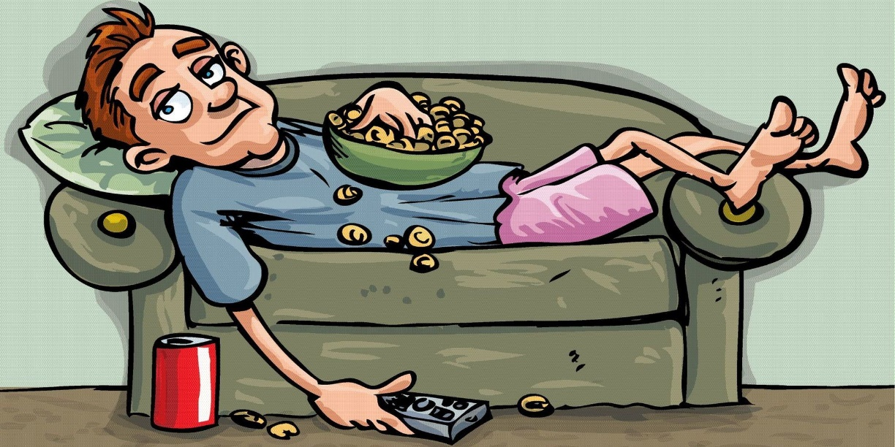

*An illustration of a lazy procrastinator Source:* <https://medium.com/@aimanhassani/theres-no-such-thing-as-laziness-535fd56acec9>

You enjoy ordering food to your door, calling your favourite persona and bugging them about how you spent your day (while they are busy working something), right from your bed.

Who doesn’t want this life!

Bham! You suddenly check your calendar and the deadline for submitting a report, an assignment or your exam is very nearby.

The fun you had all these days vanishes into the blue and now you begin to think about the task that is pending. The workload is so much that you somehow manage to submit that report, assignment or somehow pass in the exam.

THE REMEDY

After reading the juicy story of procrastination, one may wonder how to overcome this?

Well, lets look at the some of the methodologies that we can adapt in order to get away the habit of procrastinating.

* List the tasks to be done and prioritize them
  + As stated before, not knowing where to start is also a reason for procrastination. Thus, we should create a list of tasks that should be performed and prioritize them based on the urgency, complexity or other factors. This will help us get a better picture of where to start.
* Fear about the future
  + I know what you are thinking. It is true that we should not worry about the future and keep working in the present. But the level of laziness and procrastination increases to the extent that it may destroy our career & future, we should definitely think about the consequences these actions might have on our future which induces a sort of fear in ourselves that drives us to do the necessary work/task.
* Be fit, be active
  + Several researches have shown that physical fitness adds to one’s mental strength and helps reduce stress. This free mindset enables us to clearly focus on the present. So exercising daily especially early in the morning keeps our whole day fresh and we are fit to take on the world.
* Reward yourself
  + Create an action plan where you will be rewarding yourself after completing certain tasks & this will keep us motivating thought our work.

I hope we all come out of our comfort zone and start working on what we should be right now. There is not enough time in a lifetime to do all the things that we want to.

So, let us stop procrastinating and start working on our goals.

Bibliography:

1. Ellis, A., & Knaus, W. J. (1977). Overcoming procrastination. NY: Signet Books.
2. Maggie Health. (2018). Why Do People Procrastinate? 9 Reasons You Can’t Help Procrastinating [*Online]*. Available at: <https://www.lifehack.org/articles/productivity/9-common-reasons-why-procrastinate.html>